Year 10 HASS: The Modern World and Australia Target: ___________ or ____________ %

Name: __________________________

Assessment 2 (2023) - Historical Inquiry (10%)

Significant events of World War II: The use of the atomic bomb

27
- Part A – Research/Homework Task, 6%
- Part B - In-Class Validation written response, 4%

You will have 4 lessons only in class to work on part A.
Distributed: Week 5 Friday.
Due/In-class Validation: Week 7 (Wednesday)

KEY QUESTION: Consider the use of the atomic bomb during World War II and different perspectives and interpretations of this event.

Part A: - You will be required to:

- Plan your research: identify what you already know; identify what you need to find and develop some focus questions ‘to drive’ your investigation
- Compile adequate notes from the sources you examine into appropriate graphic organisers
- Select what is useful from your notes and prepare a set of dot‐point notes (10 lines) for use in the in-class validation assessment during Week 7 – these must be typed up using size 12 Arial Font – no exceptions
- Present a front cover page complete with: a suitable title; image; your name; your teacher’s name
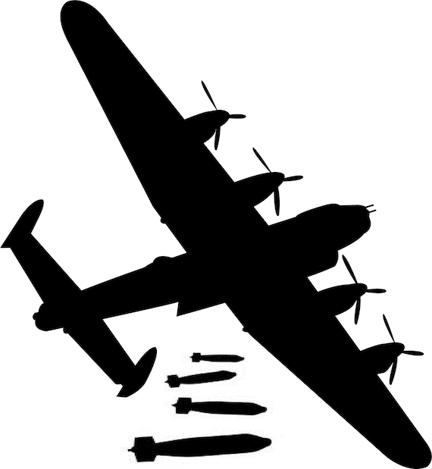
- Include a bibliography at the end of your presentation listing all of the sources. Your bibliography should appear with the sources listed alphabetically according to the author’s/organisations surname
- Double check that all items of your research are complete before handing it in
- Staple your completed research in the top left corner and place the final product in a clear sleeve
- Present your finished research on the due date: Week 7

Part B: In-Class Major Research Validation Task (4%): Week 7 (Wednesday)

Consider the use of the atomic bomb during World War II and different
perspectives and interpretations of this event.

Within a 45 minute period (no reading time), you will be required to:

- Write two extended written responses to the research questions below, using the dot‐point (10 lines) notes as a guide.

Research questions: You will be addressing in class.

In-Class Validation Task /18 (4%)

1. Explain why the United States believed it was necessary to build and use the atomic bomb. (8 marks)

2. Evaluate the decision to use the atomic bomb. Was the decision justified and ethical given the impact on Japan? Provide reasons and evidence to support your answer. (10 marks)

Assessment Two - Checklist
Complete the checklist prior to the submission of your inquiry task to reflect and ensure you have completed all aspects to the highest level.
Description | Check
Focus questions | ✓
Devises a set of questions which clearly identifies the key information needed to address
the two research questions
Devises a set of simple questions which identifies some information needed to address the
two research questions
Lists a few simple questions which identify limited information needed to address at least
one of the two research questions
Description | Check
Research hypotheses/propositions | ✓
Develops a clear hypothesis/proposition to be tested for both of the research questions
Develops a clear hypothesis/proposition to be tested for one of the research questions
Develops a simple proposition to be tested for both of the research questions
Develops a simple proposition to be tested for one of the research questions
Description | Check
Selection of information and/or data | ✓
Selects a range of relevant sources that provide clear and accurate information and/or data about the topic
Selects sources that show a variety of perspectives
Selects a few sources that provide some information and/or data about the topic
Selects sources that show some differences in perspectives
Uses one or two sources that provide limited information about the topic
Description | Check
Organisation of information and/or data | ✓
Organises information and/or data into clear categories using appropriate graphic organisers and subheadings
Organises information and/or data into some categories using graphic organisers and subheadings
Organises information and/or data in a limited fashion
Description | Check
Bibliography | ✓
Follows correct format as approved by the school
Lists sources used

Year 10 HASS: The Modern World and Australia Target: ____/ 27 or _______ %

NAME: _______________________________________

Assessment 2 – Part A - Historical Inquiry
Major Research Task / 27 (6%)

MARKS | 0 | 1 | 2 | 3 | 4 | 5
Planning: Quality & usefulness of Action Plan, Brainstorm, KWL etc.
Questions: Develop some useful focus questions to drive your investigation
Notes: Evidence of effective & comprehensive notetaking using appropriate graphic organisers
Dot points: A sheet comprising of 10 lines of relevant information – size 12 Arial Font (Must be typed)
See example in class
Bibliography: Display a reference to a wide range of websites, books, DVDs, journals etc. List these alphabetically using the required format
Cover Page: Student Name , Teacher’s Name, Title, Image
TOTAL MARKS:  / 27 | Comment:
MARKING KEY GUIDE

Planning: Quality & usefulness of Action Plan, Brainstorm, KWL etc. | Students must: provide a timeline plan of what they aim to do and when to complete each part of the task; submit a neat and detailed brainstorm of what they know and create a document to show they wish to find out (this will help you to devise some good questions). Once the research is complete, present a summary of what you have learnt.
Questions: Develop some useful focus questions to drive your investigation | Good questions help you to focus on the set task – information that answers those questions, becomes the information you need to find
Notes: Evidence of effective & comprehensive notetaking | Suitable note taking formats must be presented containing all notes created, ideally sorted under specific questions or subtitles, along with a reference of the source the notes came from.
Dot points: A sheet comprising of 10 lines of relevant information | Present a one sided document consisting of only 10 lines of information to be used as your notes for the in-class component. Typed, size 12 Arial font. Think carefully about the quality of your notes, they should be based upon the research questions set
Bibliography: Display a reference to a wide range of websites. List these alphabetically using the required format | Neatly title a sheet ‘Bibliography’ and presented a list of ALL website sources examined, presented in alphabetical order according to the authors’ surnames/organisation name, followed by the title (underlined); full web address, date accessed, date published with a range of at least four different websites is expected.
Cover Page: Student Name , Teacher’s Name, Title, Image | A cover page clearly stating student’s name and teacher’s name. Title of the task and an appropriate image with a caption.

